**Lab Document for Syntax Analyzer**

**a)Motivation/Aim**

利用自底向上方式对输入的字符流进行简单的语法分析，并返回归约序列。

**b)Content description**

程序以java编写，包含Parser、LexicalAnalyzer、Formatter、FileHelper四个类，其中Parser为启动类，其首先利用LexicalAnalyzer.tokenizer()分析input.txt中的输入生成词法单元序列tokens输出到tokens.txt，再借由ArrayList<String> tokenList=Formatter.transform()将tokens.txt中的词法单元简化并输出到simp_tokens.txt，最后根据事先构建的LR(1)翻译表进行语法分析，而FileHelper为封装文件操作的工具类，包含文件创建及读写的方法。

**c)Ideas/Methods**

1)Construct LR(1) parsing table based on the CFG

2)Design the program using LR(1) paring table

具体细节在文档后续内容提及，此处先略过。

**d)Assumptions**

预先定义的CFG如下（原始定义文法状态过多，故采用简化后的文法）：

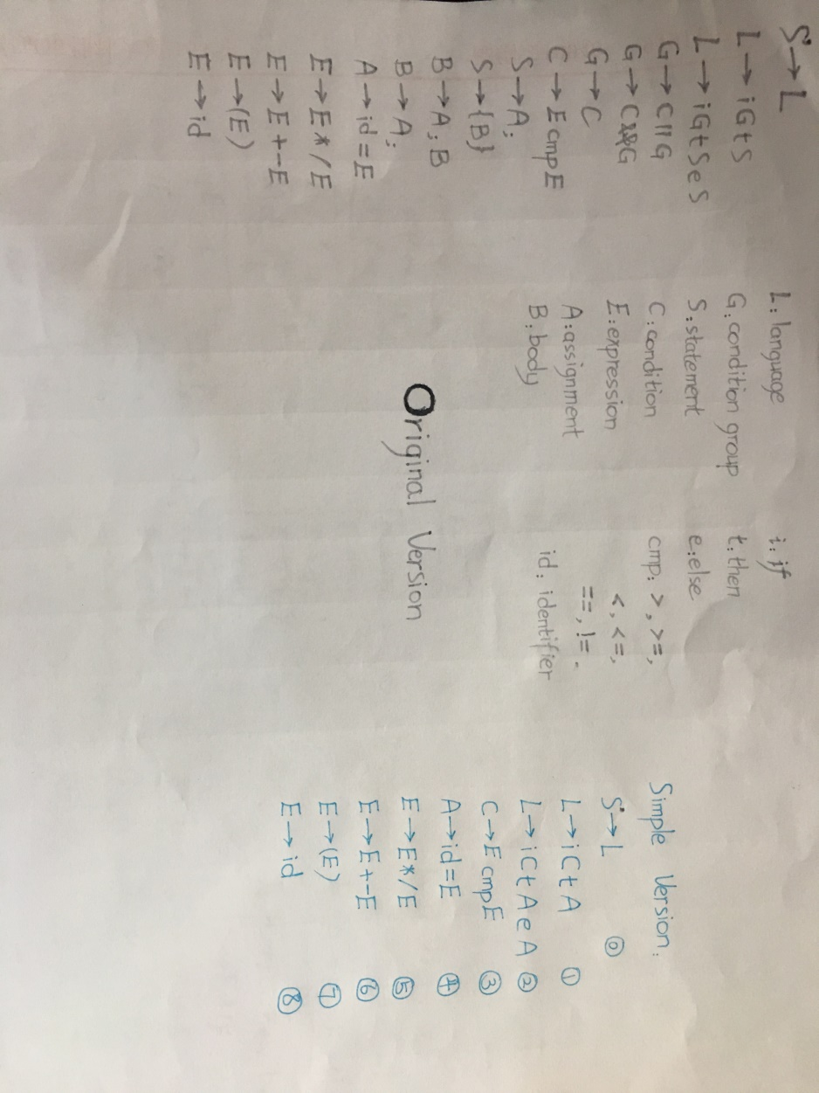

构建语法分析表的过程：

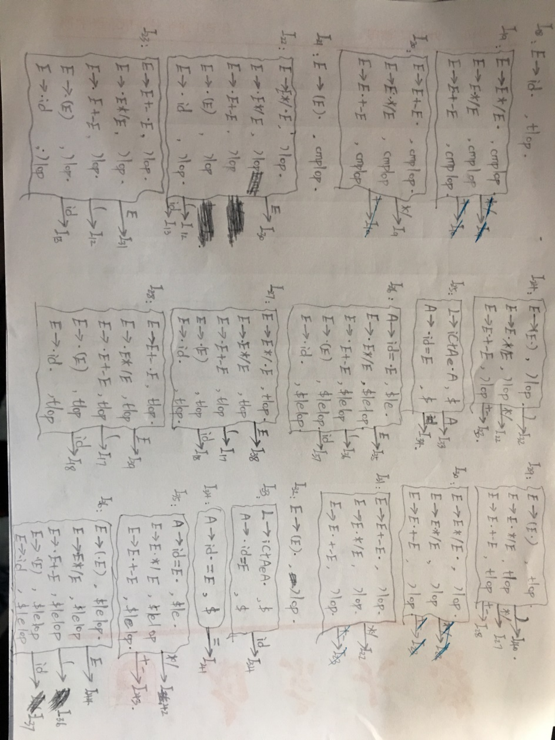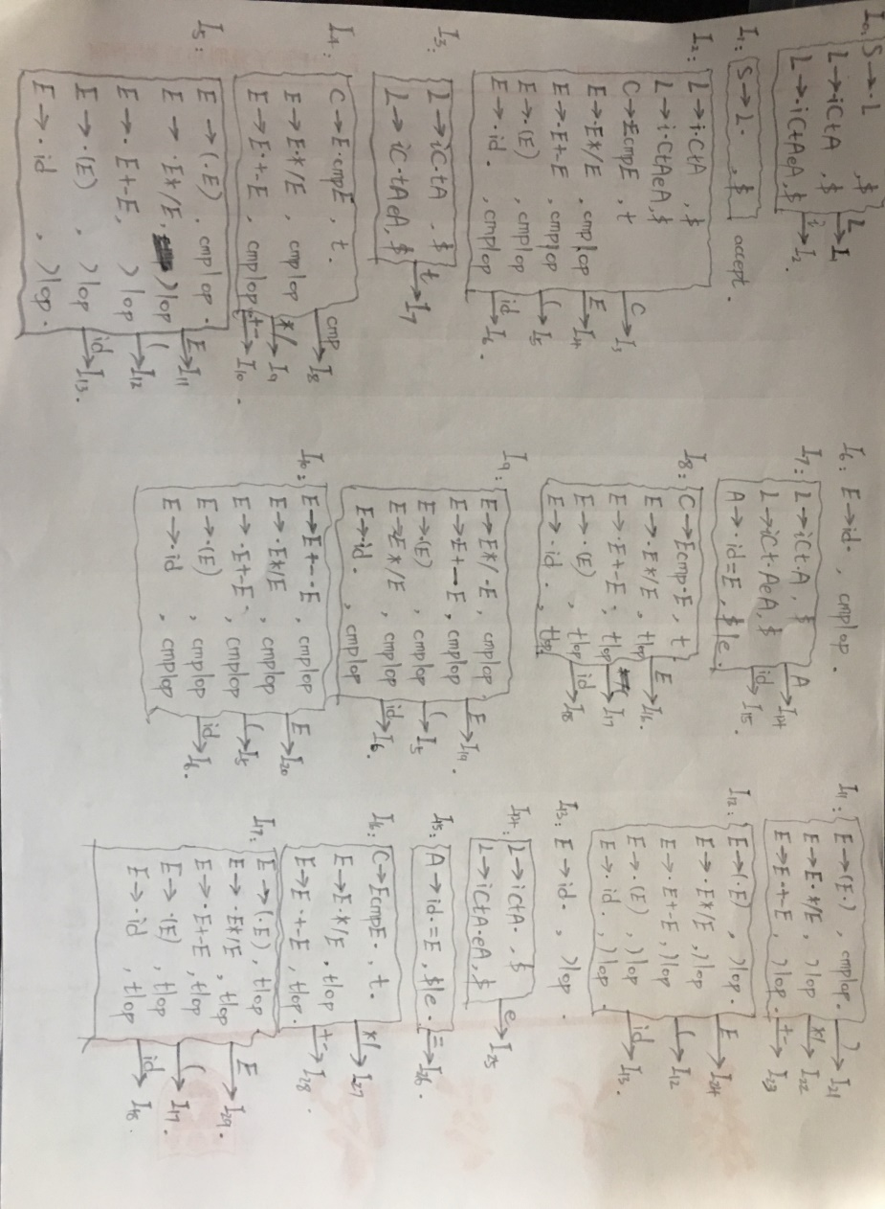  


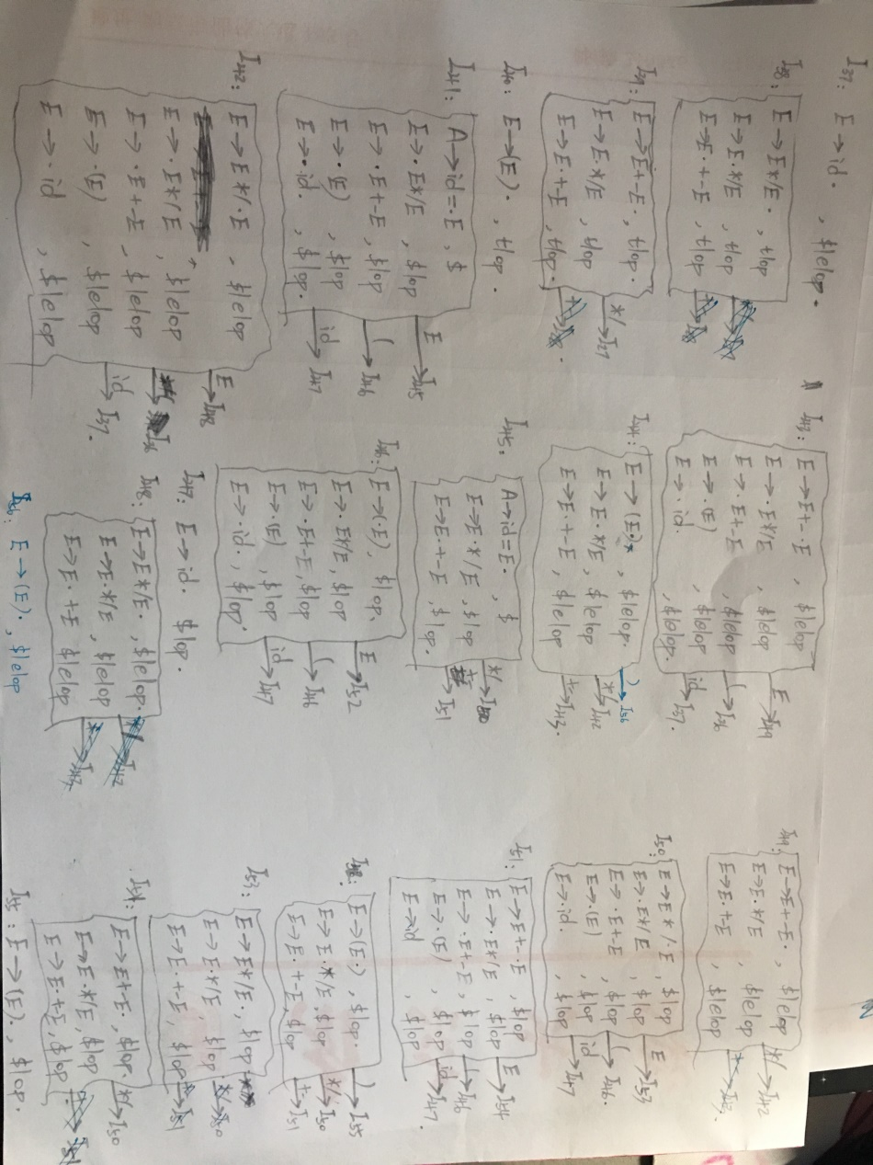

**e)Related FA descriptions**

LR(1) parsing table如下：

|  |  |  |  |  |  |  |  |  |  |  |  |  |  |  |  |
| --- | --- | --- | --- | --- | --- | --- | --- | --- | --- | --- | --- | --- | --- | --- | --- |
| State | Action | | | | | | | | | | | goto | | | |
| i | t | e | cmp | id | ( | ) | */ | +- | = | $ | L | C | E | A |
| 0 | S2 |  |  |  |  |  |  |  |  |  |  | S1 |  |  |  |
| 1 |  |  |  |  |  |  |  |  |  |  | ACC |  |  |  |  |
| 2 |  |  |  |  | S6 | S5 |  |  |  |  |  |  | S3 | S4 |  |
| 3 |  | S7 |  |  |  |  |  |  |  |  |  |  |  |  |  |
| 4 |  |  |  | S8 |  |  |  | S9 | S10 |  |  |  |  |  |  |
| 5 |  |  |  |  | S13 | S12 |  |  |  |  |  |  |  | S11 |  |
| 6 |  |  |  | R8 | R8 |  |  |  |  |  |  |  |  |  |  |
| 7 |  |  |  |  | S15 |  |  |  |  |  |  |  |  |  | S14 |
| 8 |  |  |  |  | S18 | S17 |  |  |  |  |  |  |  | S16 |  |
| 9 |  |  |  |  | S6 | S5 |  |  |  |  |  |  |  | S19 |  |
| 10 |  |  |  |  | S6 | S5 |  |  |  |  |  |  |  | S20 |  |
| 11 |  |  |  |  |  |  | S21 | S22 | S23 |  |  |  |  |  |  |
| 12 |  |  |  |  | S13 | S12 |  |  |  |  |  |  |  | S24 |  |
| 13 |  |  |  |  |  |  | R8 | R8 | R8 |  |  |  |  |  |  |
| 14 |  |  | S25 |  |  |  |  |  |  |  | R1 |  |  |  |  |
| 15 |  |  |  |  |  |  |  |  |  | S26 |  |  |  |  |  |
| 16 |  | R3 |  |  |  |  |  | S27 | S28 |  |  |  |  |  |  |
| 17 |  |  |  |  | S18 | S17 |  |  |  |  |  |  |  | S29 |  |
| 18 |  | R8 |  |  |  |  |  | R8 | R8 |  |  |  |  |  |  |
| 19 |  |  |  | R5 |  |  |  | R5 | R5 |  |  |  |  |  |  |
| 20 |  |  |  | R6 |  |  |  | S9 | R6 |  |  |  |  |  |  |
| 21 |  |  |  | R7 |  |  |  | R7 | R7 |  |  |  |  |  |  |
| 22 |  |  |  |  | S13 | S12 |  |  |  |  |  |  |  | S30 |  |
| 23 |  |  |  |  | S13 | S12 |  |  |  |  |  |  |  | S31 |  |
| 24 |  |  |  |  |  |  | S32 | S22 | S23 |  |  |  |  |  |  |
| 25 |  |  |  |  | S34 |  |  |  |  |  |  |  |  |  | S33 |
| 26 |  |  |  |  | S37 | S36 |  |  |  |  |  |  |  | S35 |  |
| 27 |  |  |  |  | S18 | S17 |  |  |  |  |  |  |  | S38 |  |
| 28 |  |  |  |  | S18 | S17 |  |  |  |  |  |  |  | S39 |  |
| 29 |  |  |  |  |  |  | S40 | S27 | S28 |  |  |  |  |  |  |
| 30 |  |  |  |  |  |  | R5 | R5 | R5 |  |  |  |  |  |  |
| 31 |  |  |  |  |  |  | R6 | S22 | R6 |  |  |  |  |  |  |
| 32 |  |  |  |  |  |  | R7 | R7 | R7 |  |  |  |  |  |  |
| 33 |  |  |  |  | S34 |  |  |  |  |  | R2 |  |  |  |  |
| 34 |  |  |  |  |  |  |  |  |  | S41 |  |  |  |  |  |
| 35 |  |  | R4 |  |  |  |  | S42 | S43 |  | R4 |  |  |  |  |
| 36 |  |  |  |  | S37 | S36 |  |  |  |  |  |  |  | S44 |  |
| 37 |  |  | R8 |  |  |  |  | R8 | R8 |  | R8 |  |  |  |  |
| 38 |  | R5 |  |  |  |  |  | R5 | R5 |  |  |  |  |  |  |
| 39 |  | R6 |  |  |  |  |  | S27 | R6 |  |  |  |  |  |  |
| 40 |  | R7 |  |  |  |  |  | R7 | R7 |  |  |  |  |  |  |
| 41 |  |  |  |  | S47 | S46 |  |  |  |  |  |  |  | S45 |  |
| 42 |  |  |  |  | S37 | S36 |  |  |  |  |  |  |  | S48 |  |
| 43 |  |  |  |  | S37 | S36 |  |  |  |  |  |  |  | S49 |  |
| 44 |  |  |  |  |  |  | S56 | S42 | S43 |  |  |  |  |  |  |
| 45 |  |  |  |  |  |  |  | S50 | S51 |  | R4 |  |  |  |  |
| 46 |  |  |  |  | S47 | S46 |  |  |  |  |  |  |  | S52 |  |
| 47 |  |  |  |  |  |  |  | R8 | R8 |  | R8 |  |  |  |  |
| 48 |  |  | R5 |  |  |  |  | R5 | R5 |  | R5 |  |  |  |  |
| 49 |  |  | R6 |  |  |  |  | S42 | R6 |  | R6 |  |  |  |  |
| 50 |  |  |  |  | S47 | S46 |  |  |  |  |  |  |  | S53 |  |
| 51 |  |  |  |  | S47 | S46 |  |  |  |  |  |  |  | S54 |  |
| 52 |  |  |  |  |  |  | S55 | S50 | S51 |  |  |  |  |  |  |
| 53 |  |  |  |  |  |  |  | R5 | R5 |  | R5 |  |  |  |  |
| 54 |  |  |  |  |  |  |  | S50 | R6 |  | R6 |  |  |  |  |
| 55 |  |  |  |  |  |  |  | R7 | R7 |  | R7 |  |  |  |  |
| 56 |  |  | R7 |  |  |  |  | R7 | R7 |  | R7 |  |  |  |  |

PS: Using Precedence and Associativity to Resolve Parsing Action Conflicts

**f)Description of important Data Structures**

//程序内语法分析表以二维整型数组表示  
//其中正数表示移入，负数表示归约，0表示Error，Integer.MAX_VALUE表示Accept  
public static int[][] parsingTb = {  
      {2,0,0,0,0,0,0,0,0,0,0,1,0,0,0},  
      {0,0,0,0,0,0,0,0,0,0,Integer.MAX_VALUE,0,0,0,0},  
      {0,0,0,0,6,5,0,0,0,0,0,0,3,4,0},  
      {0,7,0,0,0,0,0,0,0,0,0,0,0,0,0},  
      {0,0,0,8,0,0,0,9,10,0,0,0,0,0,0},  
      {0,0,0,0,13,12,0,0,0,0,0,0,0,11,0},  
      {0,0,0,-8,-8,0,0,0,0,0,0,0,0,0,0},  
      {0,0,0,0,15,0,0,0,0,0,0,0,0,0,14},  
      {0,0,0,0,18,17,0,0,0,0,0,0,0,16,0},  
      {0,0,0,0,6,5,0,0,0,0,0,0,0,19,0},  
      {0,0,0,0,6,5,0,0,0,0,0,0,0,20,0},  
      {0,0,0,0,0,0,21,22,23,0,0,0,0,0,0},  
      {0,0,0,0,13,12,0,0,0,0,0,0,0,24,0},  
      {0,0,0,0,0,0,-8,-8,-8,0,0,0,0,0,0},  
      {0,0,25,0,0,0,0,0,0,0,-1,0,0,0,0},  
      {0,0,0,0,0,0,0,0,0,26,0,0,0,0,0},  
      {0,-3,0,0,0,0,0,27,28,0,0,0,0,0,0},  
      {0,0,0,0,18,17,0,0,0,0,0,0,0,29,0},  
      {0,-8,0,0,0,0,0,-8,-8,0,0,0,0,0,0},  
      {0,0,0,-5,0,0,0,-5,-5,0,0,0,0,0,0},  
      {0,0,0,-6,0,0,0,9,-6,0,0,0,0,0,0},  
      {0,0,0,-7,0,0,0,-7,-7,0,0,0,0,0,0},  
      {0,0,0,0,13,12,0,0,0,0,0,0,0,30,0},  
      {0,0,0,0,13,12,0,0,0,0,0,0,0,31,0},  
      {0,0,0,0,0,0,32,22,23,0,0,0,0,0,0},  
      {0,0,0,0,34,0,0,0,0,0,0,0,0,0,33},  
      {0,0,0,0,37,36,0,0,0,0,0,0,0,35,0},  
      {0,0,0,0,18,17,0,0,0,0,0,0,0,38,0},  
      {0,0,0,0,18,17,0,0,0,0,0,0,0,39,0},  
      {0,0,0,0,0,0,40,27,28,0,0,0,0,0,0},  
      {0,0,0,0,0,0,-5,-5,-5,0,0,0,0,0,0},  
      {0,0,0,0,0,0,-6,22,-6,0,0,0,0,0,0},  
      {0,0,0,0,0,0,-7,-7,-7,0,0,0,0,0,0},  
      {0,0,0,0,34,0,0,0,0,0,-2,0,0,0,0},  
      {0,0,0,0,0,0,0,0,0,41,0,0,0,0,0},  
      {0,0,-4,0,0,0,0,42,43,0,-4,0,0,0,0},  
      {0,0,0,0,37,36,0,0,0,0,0,0,0,44,0},  
      {0,0,-8,0,0,0,0,-8,-8,0,-8,0,0,0,0},  
      {0,-5,0,0,0,0,0,-5,-5,0,0,0,0,0,0},  
      {0,-6,0,0,0,0,0,27,-6,0,0,0,0,0,0},  
      {0,-7,0,0,0,0,0,-7,-7,0,0,0,0,0,0},  
      {0,0,0,0,47,46,0,0,0,0,0,0,0,45,0},  
      {0,0,0,0,37,36,0,0,0,0,0,0,0,48,0},  
      {0,0,0,0,37,36,0,0,0,0,0,0,0,49,0},  
      {0,0,0,0,0,0,56,42,43,0,0,0,0,0,0},  
      {0,0,0,0,0,0,0,50,51,0,-4,0,0,0,0},  
      {0,0,0,0,47,46,0,0,0,0,0,0,0,52,0},  
      {0,0,0,0,0,0,0,-8,-8,0,-8,0,0,0,0},  
      {0,0,-5,0,0,0,0,-5,-5,0,-5,0,0,0,0},  
      {0,0,-6,0,0,0,0,42,-6,0,-6,0,0,0,0},  
      {0,0,0,0,47,46,0,0,0,0,0,0,0,53,0},  
      {0,0,0,0,47,46,0,0,0,0,0,0,0,54,0},  
      {0,0,0,0,0,0,55,50,51,0,0,0,0,0,0},  
      {0,0,0,0,0,0,0,-5,-5,0,-5,0,0,0,0},  
      {0,0,0,0,0,0,0,50,-6,0,-6,0,0,0,0},  
      {0,0,0,0,0,0,0,-7,-7,0,-7,0,0,0,0},  
      {0,0,-7,0,0,0,0,-7,-7,0,-7,0,0,0,0}  
};

//输入符号到其索引的映射  
Map<String, Integer> map = new HashMap<String, Integer>();  
​  
//产生式编号到相应产生式的映射  
Map<Integer,String> prodMap=new HashMap<>();  
​  
//产生式编号到产生式体符号个数的映射  
Map<Integer,Integer> bodyMap=new HashMap<>();  
​  
//产生式编号到产生式头非终结符的映射  
Map<Integer,String> headMap=new HashMap<>();  
​  
//用来保存语法分析器状态的栈  
Stack stateStack = new Stack<Integer>();  
stateStack.push(0);//初始时仅含状态0  
​  
int cur_state;//栈顶状态  
int symbol;//当前输入符号在语法分析表对应索引  
int action;//翻译表所采取动作  
ArrayList<String> reductions=new ArrayList<>();//保存归约式子的链表  
String s="";//当前输入符号  
int index=0;//当前输入符号在简化的tokens序列中对应索引

**g)Description of core Algorithms**

先贴代码，再行分析:)

Stack stateStack = new Stack<Integer>();  
stateStack.push(0);  
int cur_state;  
int symbol;  
int action;  
ArrayList<String> reductions=new ArrayList<>();  
String s="";  
int index=0;  
while(index<tokenList.size()){  
  s=tokenList.get(index);  
  cur_state=(int)stateStack.peek();  
  symbol=map.get(s);  
  action=parsingTb[cur_state][symbol];  
  if(action==0){  
      reductions.add("Error!!!(Current State:"+cur_state+"&&Input Symbol:"+s+")");  
      break;  
  }else if(action>0){  
      if(action==Integer.MAX_VALUE){  
          if(stateStack.search(0)==2){  
              reductions.add(prodMap.get(0));  
              reductions.add("Accept!");  
              break;  
          }  
          else{  
              reductions.add(prodMap.get(0));  
              reductions.add("Unexpected End!!!");  
              break;  
          }  
      }else{  
          stateStack.push(action);  
          index++;  
      }  
  }else{  
      reductions.add(prodMap.get(-action));  
      for(int i=0;i<bodyMap.get(-action);i++){  
          stateStack.pop();  
      }  
      index--;  
      tokenList.set(index,headMap.get(-action));  
  }  
}

分析：

根据当前状态以及输入符号借由语法分析表可以得到应该采取的动作：若为数值0，则表明语法分析出错；若大于0，考虑Integer.MAX_VALUE，如果action等于最大值且栈中除当前状态外仅含状态0，说明分析结束，输入串可以接受，不然同样是语法分析出错，而action不为Integer.MAX_VALUE时则需将对应状态移入栈中并将处理序列的索引值加一；若小于0，则根据对应产生式执行归约，从栈中移除数目等同产生式体符号的状态，并把用于遍历的索引值减一，将其对应位置的简化词法单元设为产生式头。重复上述过程，直到分析过程发生错误或结束输入序列的分析。

**h)Use cases on running**

在input.txt中，有三个测试用例，执行时需保证有且只有一个用例未被注释。

//Just to have a Test  
​  
//Test 1  
/*if x>y  
then  
diff=x-y  
else  
diff=y-x*/  
​  
//Test 2  
/*if z>x+y  
then  
D_value=z-(x+y)*/  
​  
//Test 3  
/*if z>x+y  
D_value=z-(x+y)*/

其中归约序列会输出到rSequence.txt中，下面为各测试用例输出：

//Test 1  
if x>y  
then  
diff=x-y  
else  
diff=y-x  
//rSequence  
E->id  
E->id  
C->EcmpE  
E->id  
E->id  
E->E+-E  
A->id=E  
E->id  
E->id  
E->E+-E  
A->id=E  
L->iCtAeA  
S->L  
Accept!  
​  
//Test 2  
if z>x+y  
then  
D_value=z-(x+y)  
//rSequence  
E->id  
E->id  
E->id  
E->E+-E  
C->EcmpE  
E->id  
E->id  
E->E+-E  
E->id  
E->E+-E  
A->id=E  
L->iCtA  
S->L  
Accept!  
​  
//Test 3  
if z>x+y  
D_value=z-(x+y)  
//rSequence  
E->id  
E->id  
Error!!!(Current State:18&&Input Symbol:id)

**i)Problems occurred and related solutions**

错误处理的话，均会在rSequence.txt加入错误信息（代码见下）：

//出现语法分析表中未定义状态转换  
if(action==0){  
reductions.add("Error!!!(Current State:"+cur_state+"&&Input Symbol:"+s+")");  
      break;  
}

//未结束输入分析便提前读取到$并进入终止状态  
reductions.add("Unexpected End!!!");

//输入全部读取完毕，语法分析机仍未进入接受状态  
if(!reductions.get(reductions.size()-1).equals("Accept!")&&index==tokenList.size()-1){  
reductions.add("The input ends in an unacceptable state...");  
}

**j) Your feelings and comments**

语法分析器从词法分析器获取一个由词法单元组成的串，并验证这个串可以由源语言的文法生成，其常用方法可以分为自顶向下的(LL(1))和自底向上的(LR(1))。

本次实验我采用了LR(1)语法分析，相较于LL(1)而言，虽然可处理文法种类更多，但增加了复杂度（57个状态QWQ，画图画到怀疑人生）……果然，LR(1)文法还是适合YACC语法分析生成程序来做而不是人工，反正我不想再画了☹

PS(附上老师ppt上的说明…):

LL(1) grammars(often implemented by hand)

LR grammars(often constructed by automated tools)

By 161250098 彭俊杰